Strain Gauge Logger
Pete Jansen
2024-03-03

Document to describe the Strain Gauge Logger for Kelp Project

Requirements
Log Strain Gauge load data from LCM systems load shackle
LCM5096-5MCAB 4.75te Bow Shackle Load Cell c/w SubConn & 5m cab, sub 4500m

Battery powered,
10 month logging continuous at 1 sample/second
10 Hz sampling max

Design

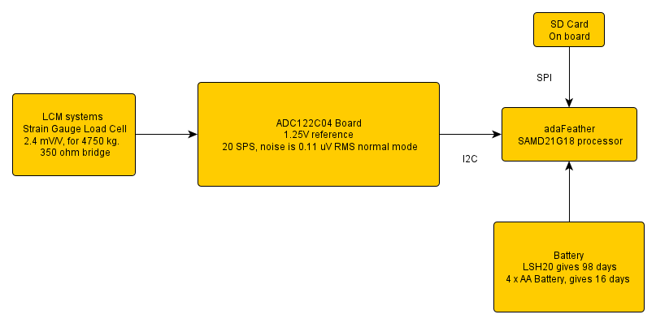

Using ATSAMD21G18 as processor with SD card attached,

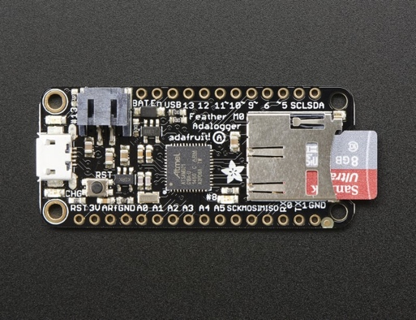

Use ADC122C04 as analog to digital converter, up to 2 ksamples/second.
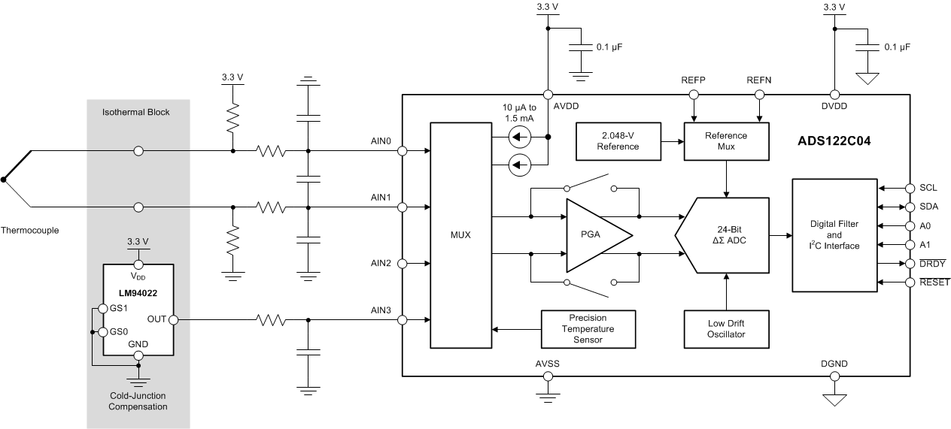

Noise is 0.11 uV rms at 20 sps, 2.048 V ref, normal mode.
0.11 * 1.25 / 2.048 = 67 nV.
Scale is 2.4 mV/V for 4.75 t,
with 1.25 V ref -> 3 mV for 4.75 t
0.63 mV / t -> 630 uV/t -> 630 nV/kg
-> noise is 0.1 kg rms.

Power

Feather standby current (no mods) 540 uA
Standby current (reg removed) 70 uA
IDLE2 8 MHz 2.6 mA
IDLE2 48 MHz 14 mA

Running, from Battery at 5.2 V, 970 uA, 1 sample/second

- LSH20 – 3.6 V to 2.0 V, 17 A.hr, to 3.3 V reduces to about 16.4 A.hr, capacity max at 5 mA at 20 degC. 17 A.hr @ 1 month ~ 23 mA (720 hrs).
- 4 x AA Duracell making 6V to 3.2V, 300 hrs at 10 mA, 3.016 A.hr. From 21 C to 0 C reduces service hrs from 25.4 to 20 hrs, nearly 20%.

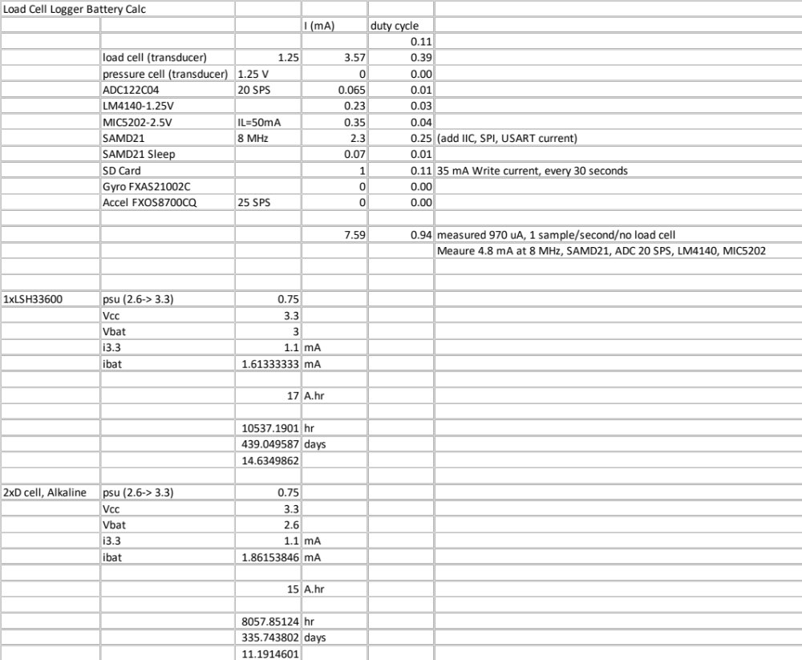

Using 2 x Alkaline D cells, at 1.1 mA 3.3 V current should get 330 days endurance, using Pololu 3.3V Step-Up Voltage Regulator U1V10F3

Software
Use Arduino development environment, which has Timer, I2C, UART, SD card, and DMA libraries

Use
uint8_t data_buffer[512 * 6 * 2];
6144 bytes data buffer, dual 3072 byte buffer which allows complete sector writes to SD card, ADC/DMA writes ½ buffer, write alternate ½ to SD card. Sample is 6 bytes, so 512 samples at 20 SPS is a write every 25 seconds.

DMA version
Sample cycle
State 0, Write ADC CMD register
State 1, txdma : send ADC START command
State 2, adc_isr : sens ADC RDATA command
State 3, txdma : read 6 bytes
State 4, rxdma : inc sample pointer, write ADC CMD reg, set state to 1

While the DMA version works, why make it so complex.

Direct version

Sample cycle
Wait Tick
Set power on to ADC
Wait power up, after 5 ms
Send config to ADC for sample,
Send START to ADC
Wait ADC ready
Send RDATA to ADC, and read 6 bytes

I2C reads and writes to look until finished, need to also timeout should ack not arrive.

Use internal SAMD21 RTC to keep time, need to set via serial connection, no battery backup.

Serial commands,

CMD cmds[] =
{
{"---", NULL, "setup commands"},
{"time", cmd_time, "display/set time <YYYY-MM-DD hh:mm:ss>"},
{"fcorr", cmd_fcorr, "display/set fcorr reg"},
{"adc", cmd_adc, "display/set adc <rate> <gain>"},
{"nburst", cmd_burst, "number of samples to burst sample"},
{"samplerate", cmd_sample, "display/set sample rate"},
{"text", cmd_text, "display/set deployment text note"},

{"---", NULL, "start/stop commands"},
{"startnow", cmd_start, "start sampling now"},
{"starttime", cmd_starttime, "set/display start time"},
{"startlater", cmd_startlater, "start sampling at starttime"},
{"startdet", cmd_startdetect, "start sampling when connected to load cell"},
{"stop", cmd_stop, "start stop sampling"},

{"set", cmd_set, "display settings"},

{"---", NULL, "debug commands"},
{"sleep", cmd_sleep, "set can sleep"},
{"debug", cmd_debug, "set debug level"},
{"regs", cmd_regs, "display all SAMD21 regs"},

{"---", NULL, "file commands"},
{"ls", cmd_ls, "display card file list"},
{"file", cmd_file, "display/set file name %Y-%M-%DT%H%M.BIN"},
{"format", cmd_format, "format card 'format yes' to format"},
{"sync", cmd_sync, "sync file"},
{"sz", cmd_sz, "send file"},
{"rz", cmd_rz, "receive file"},

{"---", NULL, "help"},
{"help", cmd_help, "command help, this message"}
};

Mechanical

Mount in SBE39 size housing, with connector in end cap, housing is 231.1 mm x 48.2 mm diam. Plastic housing is 600m depth rated.

Test Bench calibration for KELP units

On test bench, 150 ms sampling, 3 units SN 2023-01, 02 and 03

At 2023-12-20 05:22:0 tension is 2232 kg as measured by RON 5t load cell.
Tension at 2023-12-20 05:30:00 is used to determine the 0 load reading.
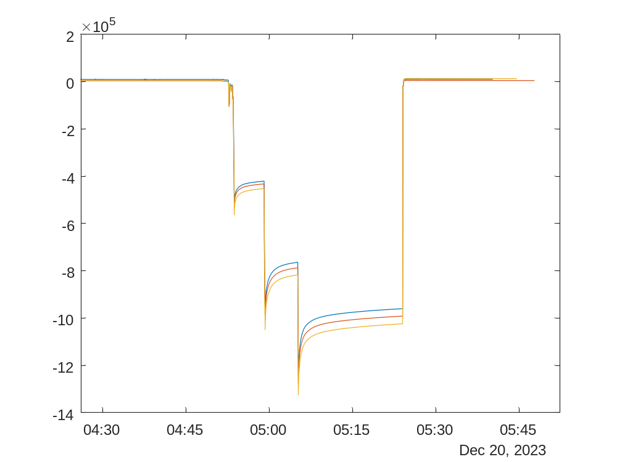

The time 05:30 to 05:40 is used to determine the noise,
SN 1 noise_mean_std = 10471 98.361
Slope is -435.97 counts/kg
SN 2 noise_mean_std = 5204.6 96.762
Slope is -447.69 counts/kg
SN 3 noise_mean_std = 13270 144.78
Slope is -465.98 counts/kg

Example sheet from LCM systems
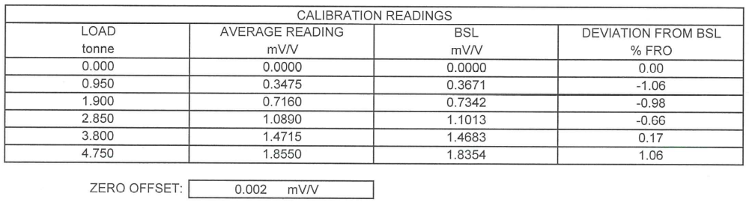
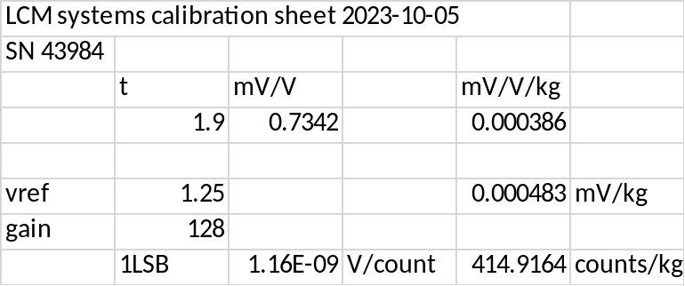

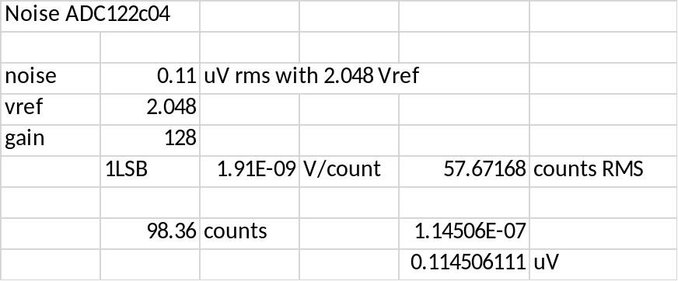

Input noise is 0.11 uV, which is close to the ADC noise.

Thermal noise in strain gauge resistor is
vn = sqrt(4.kB. T. R. dF), for 20 C, 10 Hz, 350 ohms is 7.5 nV

(kb = 1.38 e-23)

Hardware updates 2024-01-25
Change connector to mini FIT,
Add I2C pull ups,
Make enable REF and ADC 2.5V Reg separate.

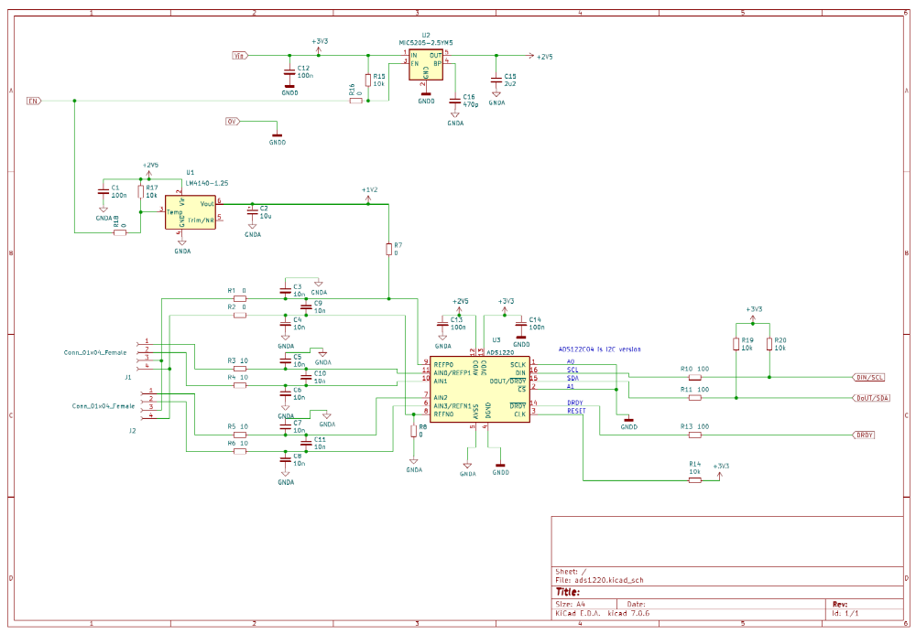

Board is 24 x 43mm
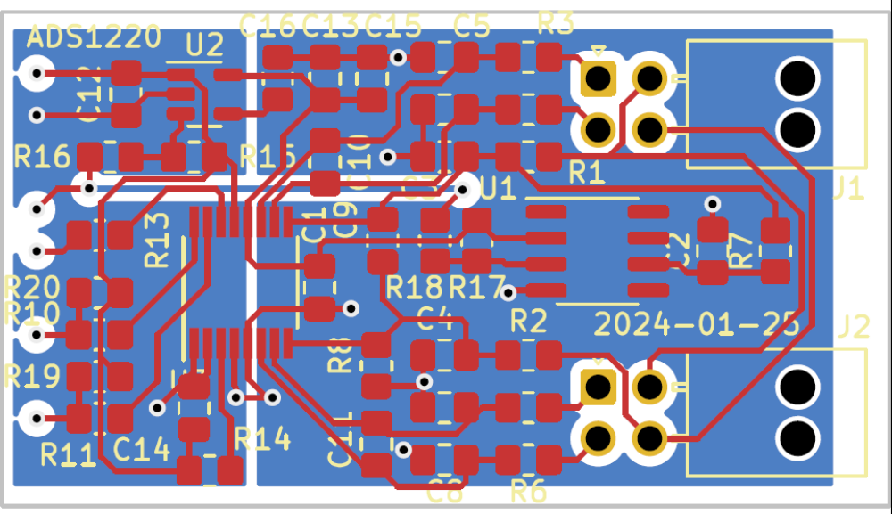

Input Capacitor

With 1000 uF capacitor on supply, starting at 3.3 V, it takes 1.48 seconds to discharge to 0.7V, where the regulator drops out to 2.15V

Average current is 1 mA.

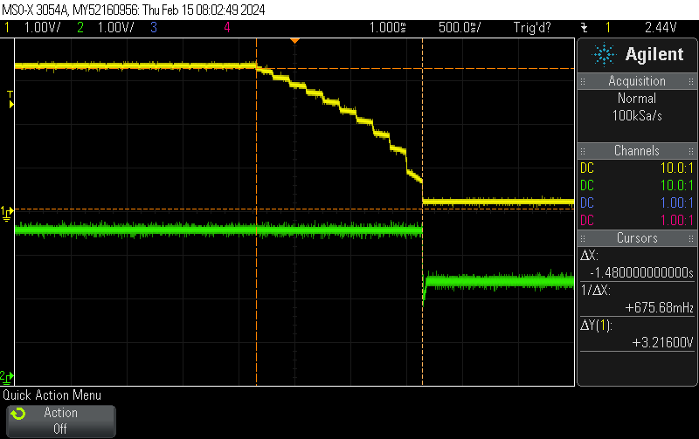

At 1V input, it takes about 100 ms for the regulator to drop out. Drawing 5mA running.

With a input capacitor of 1000 uF, should the battery disconnect for less than 100ms the logger should still run.

Using battery contact

https://au.element14.com/keystone/5251/battery-contact-spring-d-cell/dp/4049828

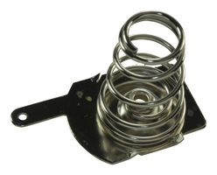
Need about 3 kg of contact pressure.
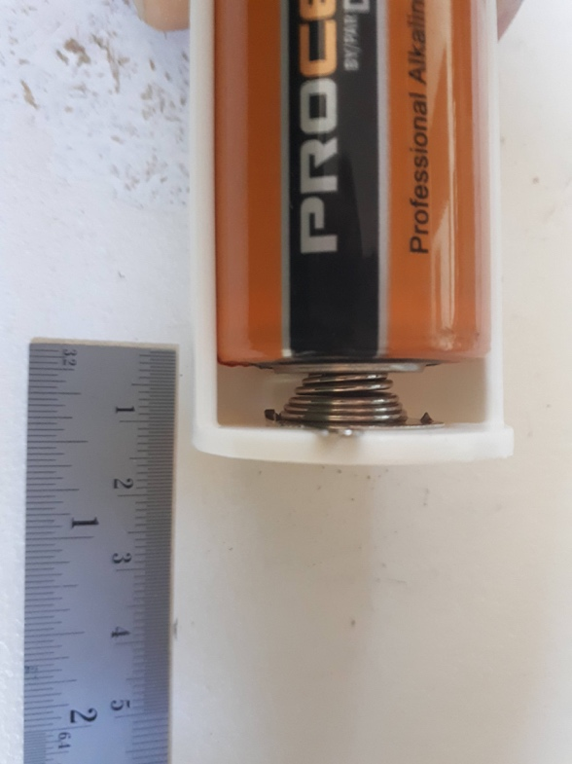

Input connection detection.

The ADS122C04 has burn out currents of 10 uA. Mode RUN_MODE_DETECT allows to start when the strain gauge is connected.
This is tested every 1 min (RTC interrupt), the sleep current is approximately 445 uA at 3V.

